**Winning the fight against fraud**

12/07/2019

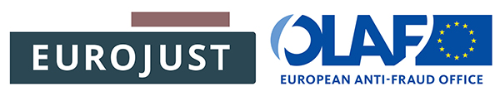

**Joint Eurojust/OLAF news item**

**OLAF and Eurojust reinforce cooperation in tackling crimes against the EU budget**

**Participants in an OLAF–Eurojust high-level meeting, which took place yesterday, agreed that early contacts to form joint investigation teams, as well as an increase in the number of coordination meetings between Eurojust National Members and investigators from the European Anti-Fraud Office (OLAF), will lead to a higher success rate in fighting crimes against the EU’s financial interests.**

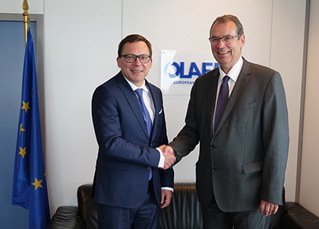While relations should be based on complementarity and full respect for each body’s area of expertise, stepping up cooperation is in the interest of both institutions in the future anti-fraud landscape. Identifying cases in which both organisations can bring added value as early as possible is of utmost importance. Mr Ladislav Hamran, President of Eurojust, said: *‘Joining our efforts will lead to better results in fighting PIF crimes and enhanced support to the national authorities. Our mandates are complementary.’*

Eurojust’s cooperation with OLAF was formalised by the [2008 Practical Agreement on arrangements of cooperation between Eurojust and OLAF](http://www.eurojust.europa.eu/doclibrary/Eurojust-framework/agreements/Practical%20Agreement%20on%20arrangements%20of%20cooperation%20between%20Eurojust%20and%20OLAF%20(2008)/Eurojust-OLAF-2008-09-24-EN.pdf). At the end of this year, the new Eurojust Regulation will enter into force, while negotiations on the reform of the OLAF Regulation started in 2018. These institutional changes and the upcoming entry into operation of the European Public Prosecutor's Office will call for adaptations in the way OLAF and Eurojust work together, while maintaining their strong ties.

Mr Ville Itälä, Director-General of OLAF, said: *‘The anti-fraud institutional landscape will change significantly once the European Public Prosecutor's Office starts functioning. OLAF and Eurojust, which will be privileged partners of the EPPO, will continue to work closely together as part of a multi-tiered system to ensure a high level of protection of the EU’s financial interests and of Europeans, particularly in the area of food fraud’.*